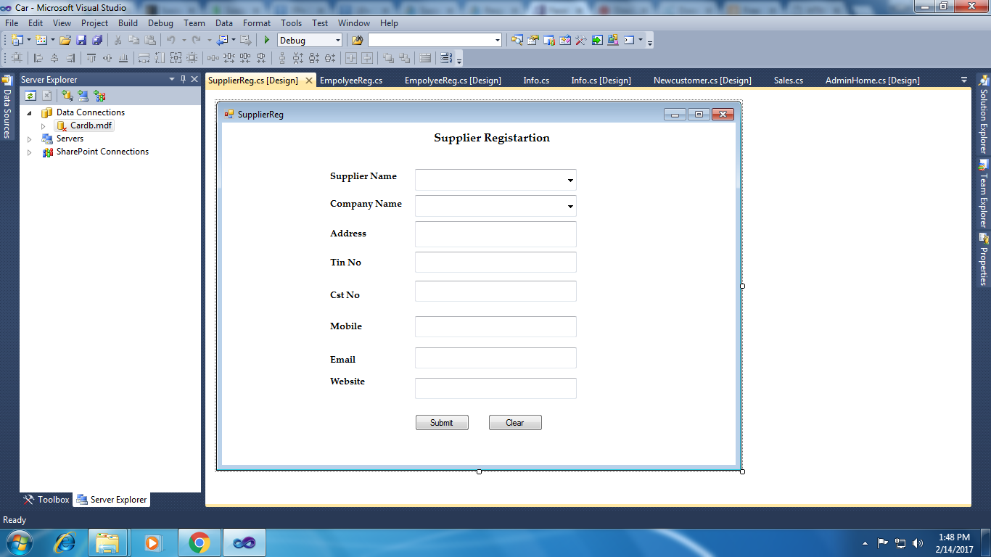

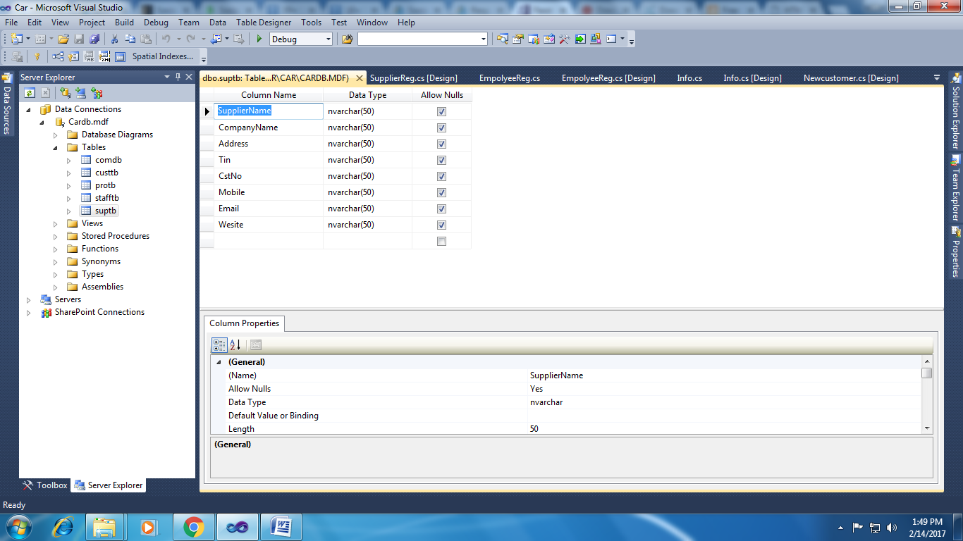using System;

using System.Collections.Generic;

using System.ComponentModel;

using System.Data;

using System.Drawing;

using System.Linq;

using System.Text;

using System.Windows.Forms;

using System.Data.SqlClient;

namespace Car

{

public partial class SupplierReg : Form

{

SqlConnection con = new SqlConnection(@"Data Source=.\SQLEXPRESS;AttachDbFilename=D:\UG College\St.Josephs College\Car\Car\Cardb.mdf;Integrated Security=True;User Instance=True");

SqlCommand cmd;

public SupplierReg()

{

InitializeComponent();

}

private void button1_Click(object sender, EventArgs e)

{

cmd = new SqlCommand("insert into comdb values('" + comboBox1.Text + "','" + textBox1.Text + "','" + textBox2.Text + "','" + textBox3.Text + "','" + textBox4.Text + "','" + textBox5.Text + "','" + textBox6.Text + "')", con);

con.Open();

cmd.ExecuteNonQuery();

con.Close();

MessageBox.Show("Record Saved!");

}

private void button2_Click(object sender, EventArgs e)

{

textBox1.Text = "";

textBox2.Text = "";

textBox3.Text = "";

textBox4.Text = "";

textBox5.Text = "";

textBox6.Text = "";

comboBox1.Text = "";

comboBox2.Text = "";

}

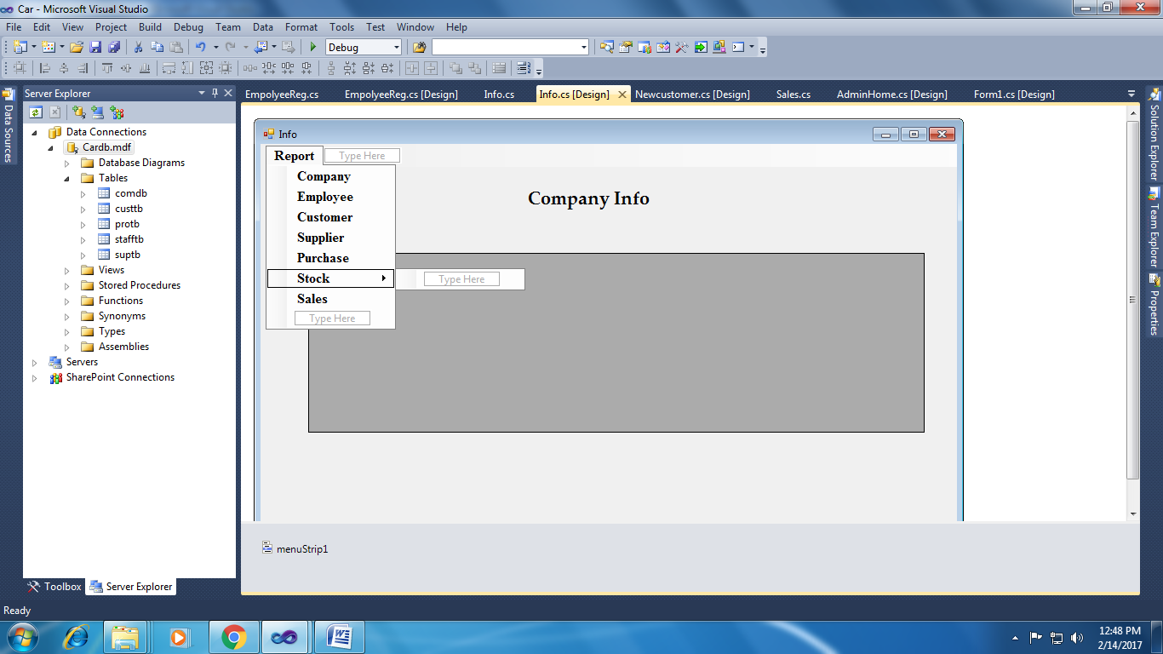

using System;

using System.Collections.Generic;

using System.ComponentModel;

using System.Data;

using System.Drawing;

using System.Linq;

using System.Text;

using System.Windows.Forms;

using System.Data.SqlClient;

namespace Car

{

public partial class Info : Form

{

SqlConnection con = new SqlConnection(@"Data Source=.\SQLEXPRESS;AttachDbFilename=G:\UG College\St.Josephs College\Car\Car\Cardb.mdf;Integrated Security=True;User Instance=True");

SqlCommand cmd;

public Info()

{

InitializeComponent();

}

private void Info_Load(object sender, EventArgs e)

{

}

private void companyToolStripMenuItem_Click(object sender, EventArgs e)

{

cmd = new SqlCommand("select * from comptb", con);

SqlDataAdapter da = new SqlDataAdapter(cmd);

DataTable dt = new DataTable();

da.Fill(dt);

dataGridView1.DataSource = dt;

dataGridView1.Refresh();

}

private void carToolStripMenuItem_Click(object sender, EventArgs e)

{

cmd = new SqlCommand("select * from stafftb", con);

SqlDataAdapter da = new SqlDataAdapter(cmd);

DataTable dt = new DataTable();

da.Fill(dt);

dataGridView1.DataSource = dt;

dataGridView1.Refresh();

}

private void customerToolStripMenuItem_Click(object sender, EventArgs e)

{

cmd = new SqlCommand("select * from custtb", con);

SqlDataAdapter da = new SqlDataAdapter(cmd);

DataTable dt = new DataTable();

da.Fill(dt);

dataGridView1.DataSource = dt;

dataGridView1.Refresh();

}

private void supplierToolStripMenuItem_Click(object sender, EventArgs e)

{

cmd = new SqlCommand("select * from suptb", con);

SqlDataAdapter da = new SqlDataAdapter(cmd);

DataTable dt = new DataTable();

da.Fill(dt);

dataGridView1.DataSource = dt;

dataGridView1.Refresh();

}

private void stockToolStripMenuItem1_Click(object sender, EventArgs e)

{

cmd = new SqlCommand("select * from protb", con);

SqlDataAdapter da = new SqlDataAdapter(cmd);

DataTable dt = new DataTable();

da.Fill(dt);

dataGridView1.DataSource = dt;

dataGridView1.Refresh();

}

}

}